Paddy Leaf Disease Detection using CNN

Nageswara Rao Moparthi1, G. Balakrishna2, J Siva Prashanth3

*1Department of Computer Science and Engineering, Koneru Lakshmaiah Education Foundation,Veddeswaram, India*

*2,3Department of Computer Science and Engineering, Anurag Group Institution, Hyderabad****.***

*Email:mnrphd@gmail./com,Me2balu@gmail.com,Rao1974@gmail.com*

**ABSTRACT : Plant diseases function as a significant threat to the food industry. The projected system helps in detection of crop diseases and provides remedies which might defend in contradiction of the crop infection. The information from the web is divided and also the totally different plant types are known and are relabeled so that we can create accurate information then get a sample database which consists of various crop diseases which will help in identifying the accuracy levels of the application . So by a training dataset we will train our classifier so the production will be predicted with best truthfulness. We tend to practice the CNN that includes various layers that are used for prediction.**

**KEYWORDS :** Convolutional Neural Network, Matlab Software, Image Processing technique, Paddy leaf disease detection, Features extraction.

**1. INTRODUCTION**

The primary occupation in India is farming. Here, agriculturalists cultivate a great diversity of crops. There are various factors such as climatic, soil and various diseases etc which affect the production of the crops reducing the ability of the crop to grow properly. Most importantly identifying the plant crop diseases and classification of it has become an easy process compared to the earlier days. However quick time, easiness and accuracy are the major factors to be kept in mind. Paddy crop disease identification and classification are dependent on the symptoms of that particular plant. Statistics show that in Asia 20%-30% of rice crop per year is destroyed by the diseases caused by the plant. Fungi and Bacteria are the main reason for the cause of these diseases. So identification of diseases in paddy crops using digital images has been chosen as the best methodology.

Deep learning is a machine language that adapts self-learning techniques used on big amounts of data. The most recent developments in hardware and big data analytics have made this technique more useful and practical as it has a fast performing system. One of the algorithms in deep learning is CNN and it is used to analyze an image and pre-process it very easily along with the help of image processing technique. The CNN models provide association between layers and also spatial information of the image to make it easy for classifying the image.

Image processing is a unique technique which undergoes some operations on a picture, so as to get an enhanced image and to extract some important helpful data from it. It’s a sort of signal process during which input is a picture and output is also a picture with additional specific features related to that of the original image. Digital image process techniques facilitate the manipulation of the digital pictures by using computers. The 3 general phases to undergo are image pre-processing, image enhancement, and image display, data extraction.

**2. LITERATURE SURVEY**

Image analysis techniques for measuring rust sickness found on soybean leaves. The methodology used is division of contaminated parts from multi-phantom pictures of soybean plant leaves which are finished utilizing quick manual edge setting strategy in light [1-2,22].

Convenient application for paddy illness with recognizable proof structure demonstrating Fluffy entropy and Probabilistic neural framework classifier that continues running on Android which is a flexible working operating system. It incorporates forms of ailments specifically darker spots, leaf impact, tungro and micro-organism leaf curse [3,13,21].

A lot of surveys on different methods of image processing applications in the agriculture field. The main focus of the area of their survey was in two streams, one is weed detection and the other one is fruit grading systems. Weed are the dangerous crops grown along with the main crops so they found them out by applying image processing techniques and collecting the images of the particular crops [4,17,26].

Completed a summary on disease classification in plant crops using image recognition techniques. These strategies are expected to be valuable for scientists giving a far detailed reaching diagram of vegetable pathology and also programmed discovery of plant ailments utilizing design acknowledgment systems [5,12,16].

The main essential paddy infections. His research was more precise in finding out the leaf impact formed because of spots, bacterial infections, leaf strength and many other factors. Shape patterns are used to dismember the piece of the injuries [6]. Discussed various data mining techniques for paddy crop disease prediction and classification [7,15].

Image Edge detection and Segmentation techniques. Initially the taken pictures are processed for enrichment at the initial stage of the process. R, G, B color, color, shape, boundaries, texture etc are the features which are extracted out from the target regions (disease spots) and later on other steps of the process continue to follow. This research includes the pest recommendations and also remedies for the diseases identified. This analysis work had a lot of great qualities but if failed to show the remedies and also could not reach the needed accuracy level [8,10,14].

A process that has only eyesight and needs precise observation and additional scientific methods and technologies. Here the images of unhealthy leaves of that particular plant are captured and the features (Hue, Saturation, and Value) are extracted once the segmentation phase is completed. ANN is trained to distinguish the healthy and unhealthy plant samples and gives 80% accuracy [19,23,24].

A model that explains about the images which are captured and stored in the database by mobile phones or any digital application. After this stage these images are analysed and judged by the senior experienced persons and a final conclusion is passed out. Computer vision techniques help in recognising the diseased places in the images and then undergo classification process. Color difference process which is a primary approach is used for the segmentation of the not well plant areas[20]. The system allows the conclusion of the senior persons and also sends the feedback to the farmers through any means of digital communication. The main goal of this proposal is to develop an image recognition system that can identify the crop diseases and help out the agriculture field and also the future generations from food crisis and economic downfall. Image processing is a picture identification system which helps in the digitization of the color image. Arithmetic science is the primary logic behind this segmentation process. Then after a little more research it is found that this process depends on mankind (drawback of many other proposals) and also the time taken to complete this process is much more than many other existing and upcoming methods [11,15,18,25].

In summary, various image processing techniques have been proposed for plant disease detection. Yet none of them proved to be efficient for identification of all kinds of paddy crop diseases.

**3. PROPOSED MODEL**

Unlike any other existing paddy crop disease detection methods, we have developed a model which runs in a very less time and also gives more accuracy along with the remedies for the disease detected in the paddy crop leaves. In this method we are using Matlab software as the platform to perform the process.

**3.1. ALGORITHM**

The algorithm for this proposed model is explained in the following steps:

1. Collecting the database and segregating it according to the features of the plant.

2. Taking an image as the test image/ input image.

3. Conversion of the image in to arrays and storing the data.

4. Training the images from datasets for the CNN classification.

4. Comparison of these both test and train images.

5. After comparison, all the features are extracted.

6. Diseases in the plant are found if there are any, remedies and the accuracy is given.

**3.2. ARCHITECTURE**

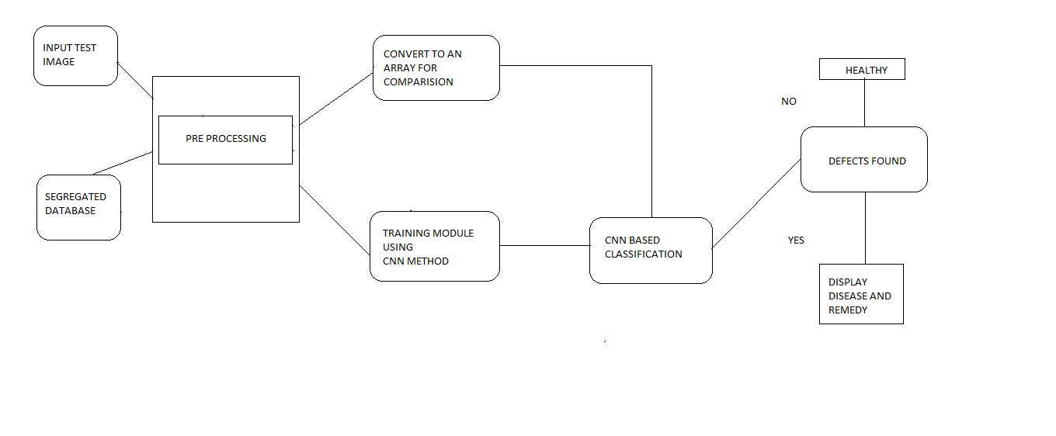

FIG 3.2 Architecture of the system

**4. MODULES**

There are 4 modules in this entire process. They are:

a. Database

b. Image pre-processing

c. CNN classification

d. Comparison of test and train images

**a. Database**

An image database means storing high quantities of digital images in a particular location. It also means organizing photos so that they can be shared, accessed quickly and easily. In this project we have taken large number of paddy leaf images into datasets.

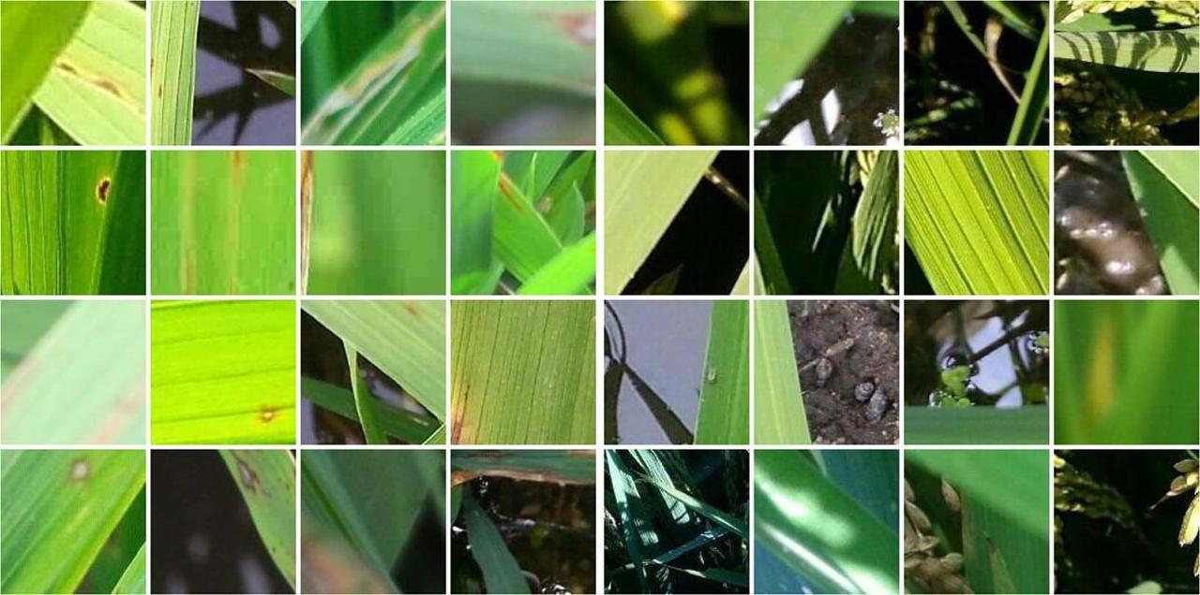

FIG 4.a Different leaves images

**b. Image pre-processing**

Image processing is a method used to perform basic operations like extraction and conversion on an image or a video, in place to get an enhanced image by getting the different features and values from it. This is a form of signal processing in which an image or set of images is taken as an input and then the result we get may be in the form of image or features associated with that image. Image processing is of two types and they are analogue and digital image processing. Analogue image processing is ideally used in the fields of photography and printings.. Digital image processing techniques help in shaping of the digital images by using digital sources and technologies. The three main steps of the digital technique process are pre-processing, enhancement, and restoration.

Using the image processing technique, we take the test images from the unhealthy plant and also along with these we train the images from the dataset so that in the pre-processing stage the features are properly extracted from the images. Some of the basic steps involved in image processing are Acquisition, Enhancement, Restoration, Compression and Segmentation.

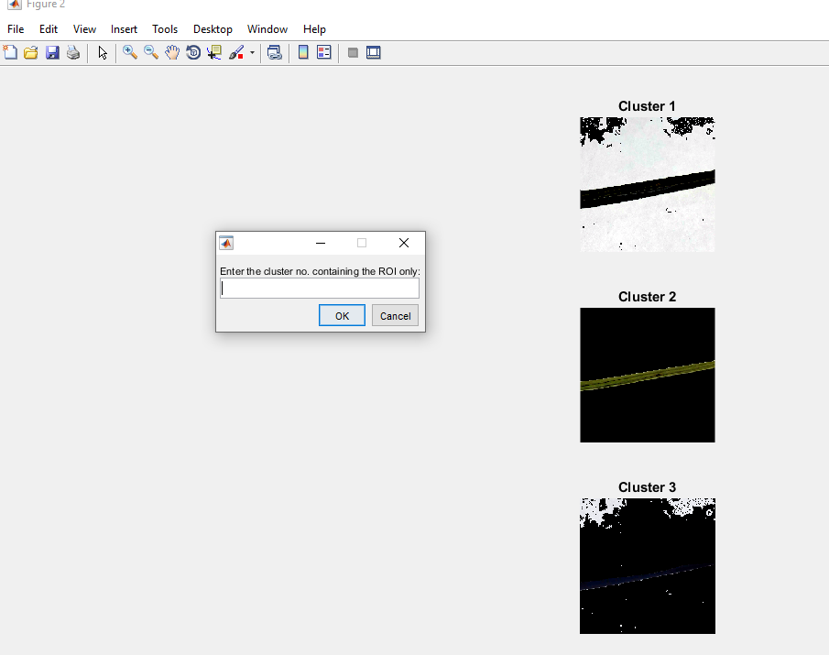

FIG 4.b Clusters formed after processing the test image

c. CNN classification

A CNN is a higher level language of deep learning. CNN models are trained using large collections of images taken across different sources. From these large collections of databases CNN models can learn rich feature extraction and presentation for a wide range of images. CNN is considered as one of the best techniques used for features extraction.

After the segmentation of image into clusters the CNN classification of these clusters happen and we get different images like black and white image, query image and also the segmented image. So once these images are formed the area affected more by the disease can be easily visible and then can be tested properly and accurately.

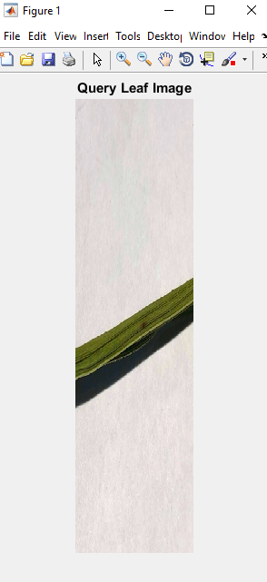

FIG 4.c B/W image and Query image

d. Comparison of test and train images:

The final stage of the process is finding whether the plant is healthy or not healthy. If there are any defects found in the image then the output will be given as yes along with the remedies to be followed for eradicating the disease. This happens when the both test and train images are brought together and are compared. The accuracy of the problem found is more when this is executed.

**5. EXECUTION AND RESULTS**

To get the exact and accurate results we are using the MATLAB software for the execution. MATLAB is a platform which is used for technical computing. MATLAB software is designed to perform various operations like computation, visualization of image, associated programming in all kinds of surrounding environments. It also involves high-level commands for 2-dimensional and 3-dimensional image visualization, image processing, presentation graphics and animation process which is one of the biggest assets of this software.

The steps involved in the execution of our model are given below respectively:

Step1 - Take an image from the dataset and give it as an input image.

Step2 - Now enter the number of the particular cluster which you want to test.

Step 3 - After this the images from the datasets are setup in the training phase which later gives us segmented image, b/w image and query leaf image.

Step 4 - In this last step, we finally get the output of the process with the disease name and the remedies to be taken to eradicate the disease. We will also get the accuracy of the disease detection.

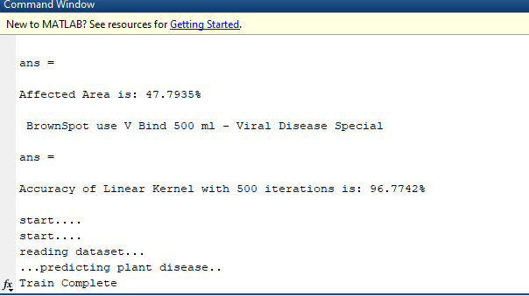

FIG 5 Step 4 – Output displayed in the command window

**6. CONCLUSION**

We proposed this system to help the farmers in gaining more productivity and also improvising agriculture systems. This methodology can detect the diseases in paddy crops and along with this it also specifies the remedies that can be used to control that particular disease. By this we can also start using new and smart technologies in the agriculture field which will bring a huge change in the Indian economy. This system is based on python language libraries and is giving an accuracy around 94% to 96%.

**7. REFERENCES**

1. Cui D., et.al., “Image Processing Methods for Quantitatively Detecting Soybean Rust from Multi-spectral Images”, Biosystems engineering, Vol.107, Issue.3, 2010, pp.186-193.
2. Vibhute A. and Bhode S K, “Applications of Image Processing in Agriculture: A Survey”, International Journal of Computer Applications, Vol. 52, Issue. 2, August 2012, pp.34-40.
3. Barbedo J C A, “Digital Image Processing Techniques for Detecting, Quantifying and Classifying Plant Diseases”, SpringerPlus, Vol.2, Issue.660, 2013, pp.1-12.
4. Auzi Asfarian, et.al.,, “Paddy Diseases Identification With Texture Analysis Using Fractal Descriptors Based On Fourier Spectrum”, International Conference On Computer, Control, Informatics And Its Applications,2013.
5. S.A. Ramesh Kumar, K.Ramesh Kumar, “a Study on Paddy Crops Disease Prediction Using Data Mining Techniques”, International Journal of Data Engineering (IJDE), Singaporean Journal of Scientific Research (SJSR), Vol.7, No.1, Pp. 336- 347, 2015.
6. P.Revathi, M.Hemalatha, “Advance Computing Enrichment Evaluation of Cotton Leaf Spot Disease Detection U sing Image Edge detection”, ICCCNT'12.
7. Malvika Ranjan, et.al., “detection and classification of leaf disease using artificial neural network”, International Journal of Technical Research and Applications, 2015.
8. Heeb Al Bashish, et.al., “A Framework for Detection and Classification of Plant Leaf and Stem Diseases”, IEEE 2010.
9. R. Mrunalini, “developer of an application of K-means clustering and artificial intelligence in pattern recognition for crop diseases”, 2011.
10. Prajapati, H. B., (2017). “Detection and classification of rice plant diseases”, (2017).
11. S. Raj Kumar, S. Sowrirajan, “Automatic Leaf Disease Detection and Classification using Hybrid Features and Supervised Classifier”, International Journal of Advanced Research in Electrical, Electronics and Instrumentation Engineering, vol. 5, Issue 6, 2016.
12. Surbhi Jain, Joydip Dhar, “Image based search engine using deep learning”, 2017 10th International conference on contemporary computing(IC 3), August 2017.
13. G Balakrishna* and Nageswara Rao Moparthi, “An Optimal IoT Device Placement Strategy for Agro-IoT using Edge Computing”, Recent Advances in Computer Science and Communications (2020) 13: 1. https://doi.org/10.2174/2666255813666191216122801
14. Pavan Kumar, T., Lala, S. K., Sravani, B., & Sandeep, A. (2018). Internet of things survey on crop field smart irrigation automation using IOT. International Journal of Engineering and Technology(UAE), 7(2.8 Special Issue 8), 503-506.
15. Umadevi, K., Lalitha, S. V. N. L., & Chetwani, S. H. (2019). Dynamic modeling for improvement in power quality issues of DFIG wind farms interconnected with grid. International Journal of Innovative Technology and Exploring Engineering, 8(5), 663-668.
16. avindran, G., Madhavi, M. R., & Abusahmin, B. S. (2018). Optimization of zinc(II) adsorption using agricultural waste. International Journal of Engineering and Technology(UAE), 7(3.34 Special Issue 34), 300-304.
17. G.Balakrishna and Moparthi Nageshwara Rao “ Study report on Indian agriculture with IoT “International Journal of Electrical and Computer Engineering
18. Somasundar, A. V. S. S., Yedukondalu, G., Subhani, S. K., Azgar, S. K., Srinivas, Y., & Ganneshwar, G. (2018). Mini paddy crop cutting and straw separation rover. Journal of Advanced Research in Dynamical and Control Systems, 10(4), 354-361.
19. Mekala, M.S., Viswanathan, P. (t,n): Sensor Stipulation with THAM Index for Smart Agriculture Decision-Making IoT System. Wireless Pers Commun 111, 1909–1940 (2020). <https://doi.org/10.1007/s11277-019-06964-0>
20. G.Balakrishna and Moparthi Nageshwara Rao,” ESBL: Design and Implement A Cloud Integrated Framework for IoT Load Balancing” International Journal Of Computers Communications & Control ISSN 1841-9836, e-ISSN 1841-9844, 14(4), 459-474, August 2019.
21. Balram, G., & Kiran Kumar, K. (2018). Smart farming: Disease detection in crops. International Journal of Engineering and Technology(UAE), 7(2), 33-36. doi:10.14419/ijet.v7i2.7.10252
22. Narayana, B. V. V. S., Ravi, K. S., & Ramesh, N. V. K. (2018). A review on advanced crop field monitoring system in agriculture field through top notch sensors. Journal of Advanced Research in Dynamical and Control Systems, 10(6 Special Issue), 1572-1578Pavan Kumar, T., Lala, S. K., Sravani, B.
23. Sandeep, A. (2018). Internet of things survey on crop field smart irrigation automation using IOT. International Journal of Engineering and Technology(UAE), 7(2.8 Special Issue 8), 503-506.
24. Narayana, B. V. V. S., & Ravi, K. S. (2017). IP camera based agricultural reforms. Journal of Advanced Research in Dynamical and Control Systems, 9(3), 19-25.
25. Navulur, S., Sastry, A. S. C. S., & Giri Prasad, M. N. (2017). Agricultural management through wireless sensors and internet of things. International Journal of Electrical and Computer Engineering, 7(6), 3492-3499.
26. Asadi, S. S., Kumar, M., Kumar, N., & Rajyalakshmi, K. (2017). Estimation of runoff for agricultural utilization using geoinformatics: A model study from telangana state. International Journal of Civil Engineering and Technology, 8(10), 472-483.